6.37: The work done in any interval is the area under the curve, easily calculated when the areas are unions of triangles and rectangles. a) The area under the trapezoid is 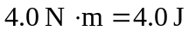. b) No force is applied in this interval, so the work done is zero. c) The area of the triangle is 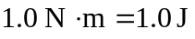, and since the curve is below the axis 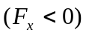, the work is negative, or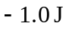. d) The net work is the sum of the results of parts (a), (b) and (c), 3.0 J. (e) 

